National Textile University, Faisalabad


Department of Computer Science

Name: | Malaika Arshad
Class: | BSCS_A 5th Semester
Registration No: | 23-NTU-CS-1043
Assignment : | Project
Course Name: | Embedded IOT
Submitted To: | Sir Nasir
Submission Date: | 26-10-2025

Project Documentation: Multi-Task ESP32 Control System

1. Project Overview
This project implements two distinct tasks—LED mode cycling (Task A) and press-type detection (Task B)—on a single ESP32 Dev Module. The system is controlled by two pushbuttons and provides visual feedback via an OLED display and audible feedback via a buzzer.

Component | Quantity | Purpose
ESP32 Dev Module | 1 | Microcontroller running the logic.
OLED Display (SSD1306, I²C) | 1 | Displays the current mode and button event.
Push Button | 2 | Inputs: one for mode cycle/reset, one for press detection.
LED (Red, Green, Blue) | 3 | Visual outputs for mode sequences and toggling.
Buzzer | 1 | Audible output for the long-press event.

TASK A:

Circuit Diagram: Design a Wokwi circuit and draw a neat hand-sketch including:
• 2 push buttons
• 3 LEDs
• 1 buzzer
• 1 OLED
Task A — Coding: Use one button to cycle through LED modes (display the current state on
the OLED):
1. Both OFF
2. Alternate blink
3. Both ON
4. PWM fade
Use the second button to reset to OFF.

TASK A :FIXED BUTTON ISSUE

WOKWI LINK :
https://wokwi.com/projects/445501799320005633

SCREENSHOT:
Both OFF:
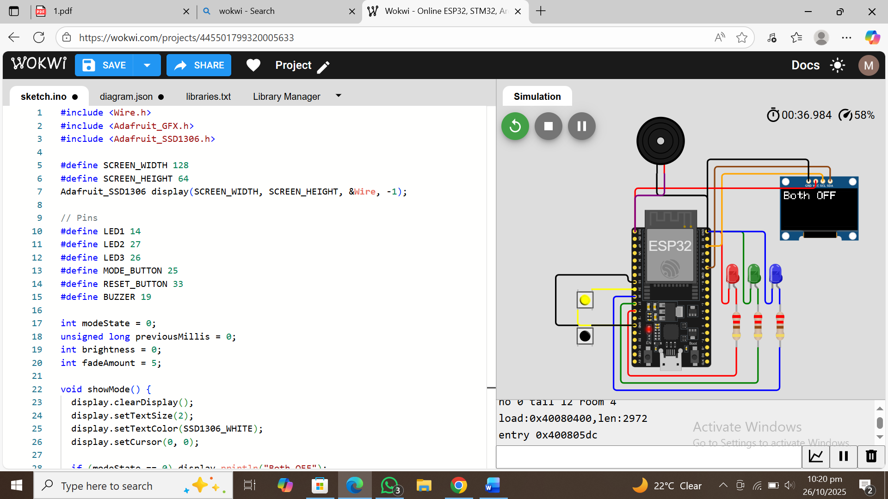

Alternate blink:
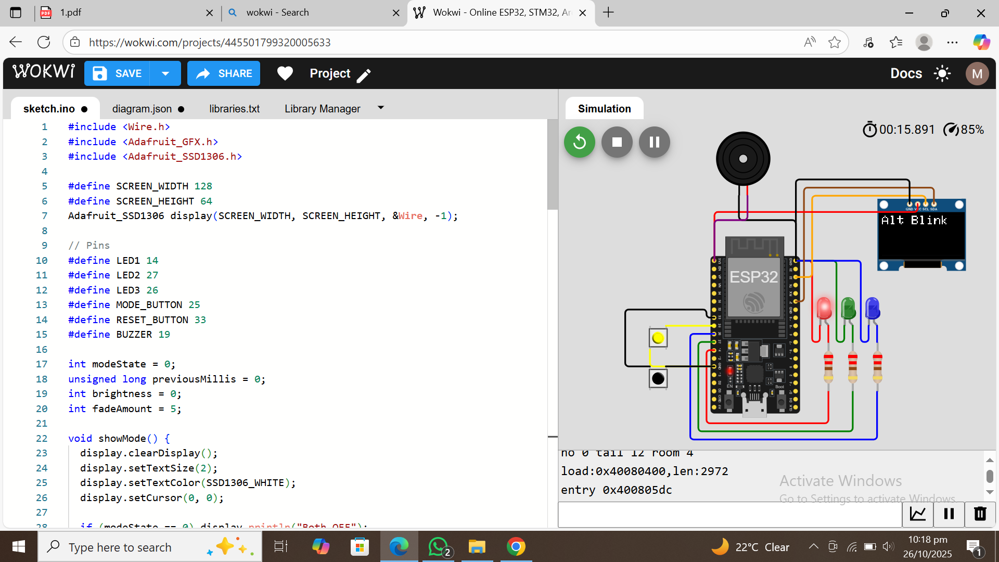

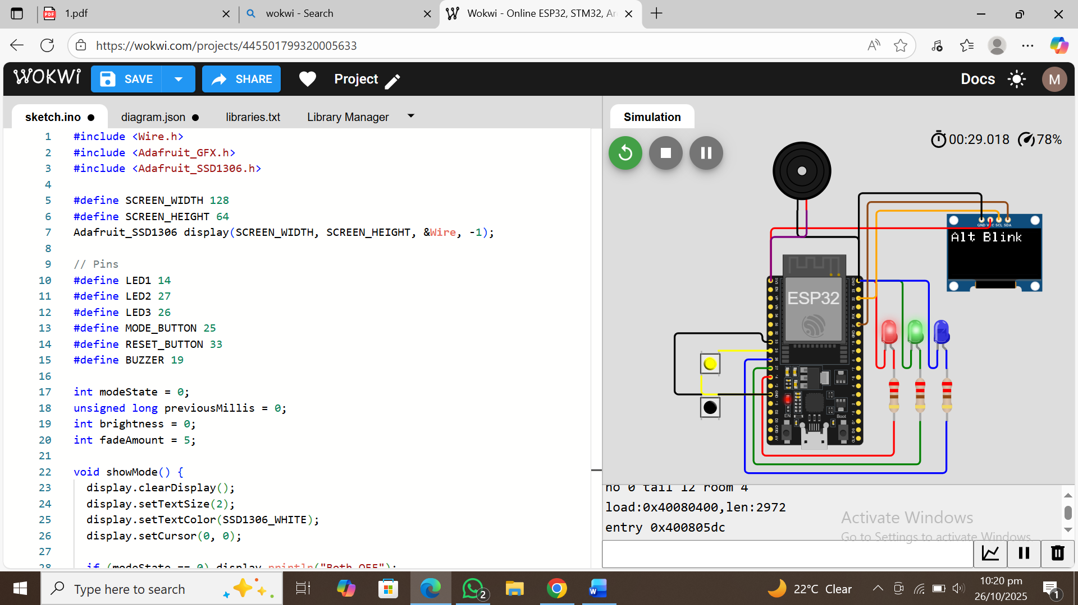

Code Of The Program:

#include <Wire.h>
#include <Adafruit_GFX.h>
#include <Adafruit_SSD1306.h>

#define SCREEN_WIDTH 128
#define SCREEN_HEIGHT 64
Adafruit_SSD1306 display(SCREEN_WIDTH, SCREEN_HEIGHT, &Wire, -1);

// Pins
#define LED1 14
#define LED2 27
#define LED3 26
#define MODE_BUTTON 25
#define RESET_BUTTON 33
#define BUZZER 19

int modeState = 0;
unsigned long previousMillis = 0;
int brightness = 0;
int fadeAmount = 5;

void showMode() {
display.clearDisplay();
display.setTextSize(2);
display.setTextColor(SSD1306_WHITE);
display.setCursor(0, 0);

if (modeState == 0) display.println("Both OFF");
if (modeState == 1) display.println("Alt Blink");
if (modeState == 2) display.println("Both ON");
if (modeState == 3) display.println("PWM Fade");

display.display();
}

void setup() {
pinMode(LED1, OUTPUT);
pinMode(LED2, OUTPUT);
pinMode(LED3, OUTPUT);
pinMode(MODE_BUTTON, INPUT_PULLUP);
pinMode(RESET_BUTTON, INPUT_PULLUP);
pinMode(BUZZER, OUTPUT);

display.begin(SSD1306_SWITCHCAPVCC, 0x3C);
showMode();
}

void loop() {

// MODE change button
if (digitalRead(MODE_BUTTON) == LOW) {
modeState = (modeState + 1) % 4;
tone(BUZZER, 700, 80);
showMode();
delay(250);
}

// RESET button
if (digitalRead(RESET_BUTTON) == LOW) {
modeState = 0;
tone(BUZZER, 400, 80);
showMode();
delay(250);
}

// MODE Behaviors
if (modeState == 0) {
digitalWrite(LED1, LOW);
digitalWrite(LED2, LOW);
digitalWrite(LED3, LOW);
}

if (modeState == 1) {
if (millis() - previousMillis >= 500) {
previousMillis = millis();
digitalWrite(LED1, !digitalRead(LED1));
digitalWrite(LED2, !digitalRead(LED1));
digitalWrite(LED3, LOW);
}
}

if (modeState == 2) {
digitalWrite(LED1, HIGH);
digitalWrite(LED2, HIGH);
digitalWrite(LED3, HIGH);
}

if (modeState == 3) {
analogWrite(LED1, brightness);
analogWrite(LED2, brightness);
analogWrite(LED3, brightness);
brightness += fadeAmount;
if (brightness <= 0 || brightness >= 255) fadeAmount = -fadeAmount;
delay(15);
}
}

TASK B:
— Coding: Use a single button with press-type detection (display the event on the OLED): • Short press → toggle LED • Long press (> 1.5 s) → play a buzzer tone.

WOKWI LINK:
https://wokwi.com/projects/445896892712775681

WORKING SCREENSHOT:
LED ON:
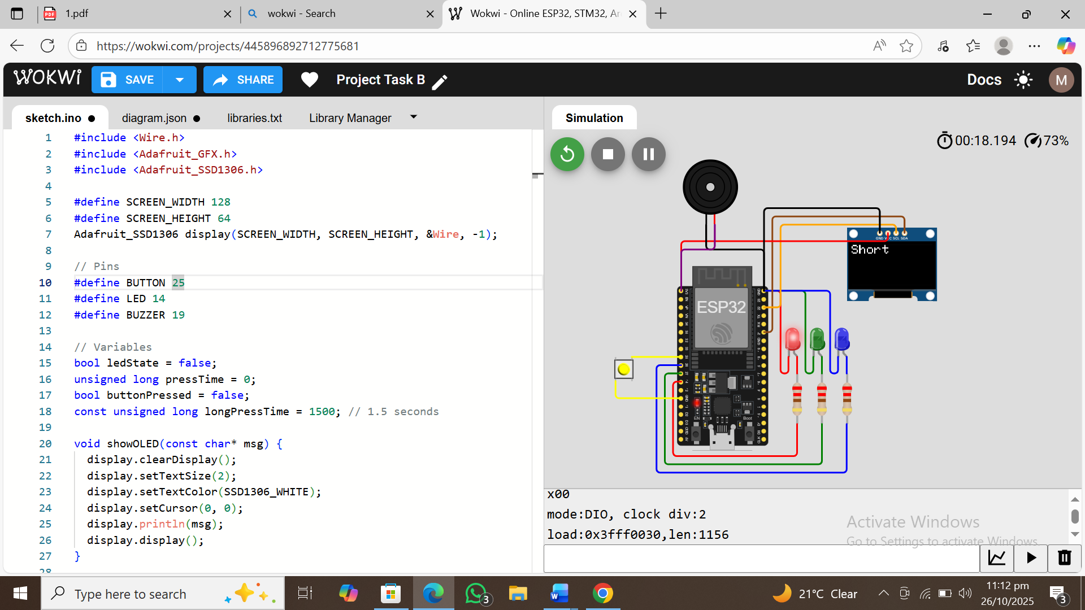
Buzzer running:
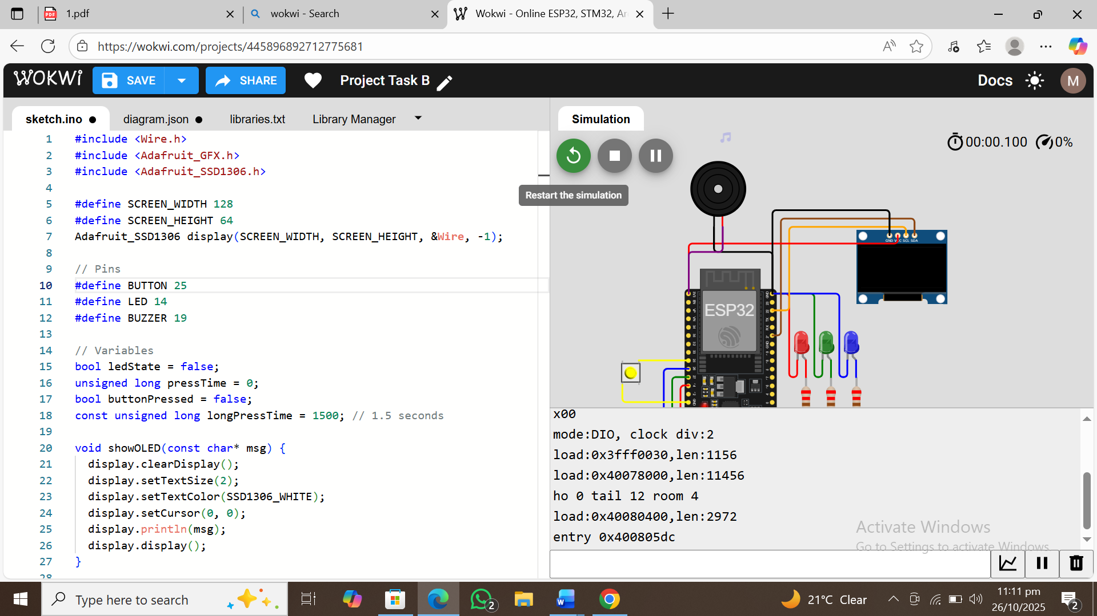

Code of the program:

#include <Wire.h>
#include <Adafruit_GFX.h>
#include <Adafruit_SSD1306.h>

#define SCREEN_WIDTH 128
#define SCREEN_HEIGHT 64
Adafruit_SSD1306 display(SCREEN_WIDTH, SCREEN_HEIGHT, &Wire, -1);

// Pins
#define BUTTON 25
#define LED 14
#define BUZZER 19

// Variables
bool ledState = false;
unsigned long pressTime = 0;
bool buttonPressed = false;
const unsigned long longPressTime = 1500; // 1.5 seconds

void showOLED(const char* msg) {
display.clearDisplay();
display.setTextSize(2);
display.setTextColor(SSD1306_WHITE);
display.setCursor(0, 0);
display.println(msg);
display.display();
}

void setup() {
pinMode(BUTTON, INPUT_PULLUP);
pinMode(LED, OUTPUT);
pinMode(BUZZER, OUTPUT);

display.begin(SSD1306_SWITCHCAPVCC, 0x3C);
showOLED("Ready");
}

void loop() {
int buttonState = digitalRead(BUTTON);

if (buttonState == LOW && !buttonPressed) {
buttonPressed = true;
pressTime = millis(); // record press time
}

if (buttonState == HIGH && buttonPressed) {
buttonPressed = false;
unsigned long pressDuration = millis() - pressTime;

if (pressDuration < longPressTime) {
// Short press
ledState = !ledState;
digitalWrite(LED, ledState);
showOLED("Short");
}
else {
// Long press
showOLED("Long");
tone(BUZZER, 800, 600); // play tone for 0.6s
}
}
}

